Project Design Phase-II

Data Flow Diagram & User Stories

|  |  |
| --- | --- |
| Date | 03 October 2022 |
| Team ID | PNT2022TMID34052 |
| Project Name | Project - Analytics for hospital health care data |
| Maximum Marks | 4 Marks |

# Data Flow Diagrams:

A Data Flow Diagram (DFD) is a traditional visual representation of the information flows within a system. A neat and clear DFD can depict the right amount of the system requirement graphically. It shows how data enters and leaves the system, what changes the information, and where data is stored.

# DATA FLOW DIAGRAM OF HOSPITAL HEALTH CARE DATA

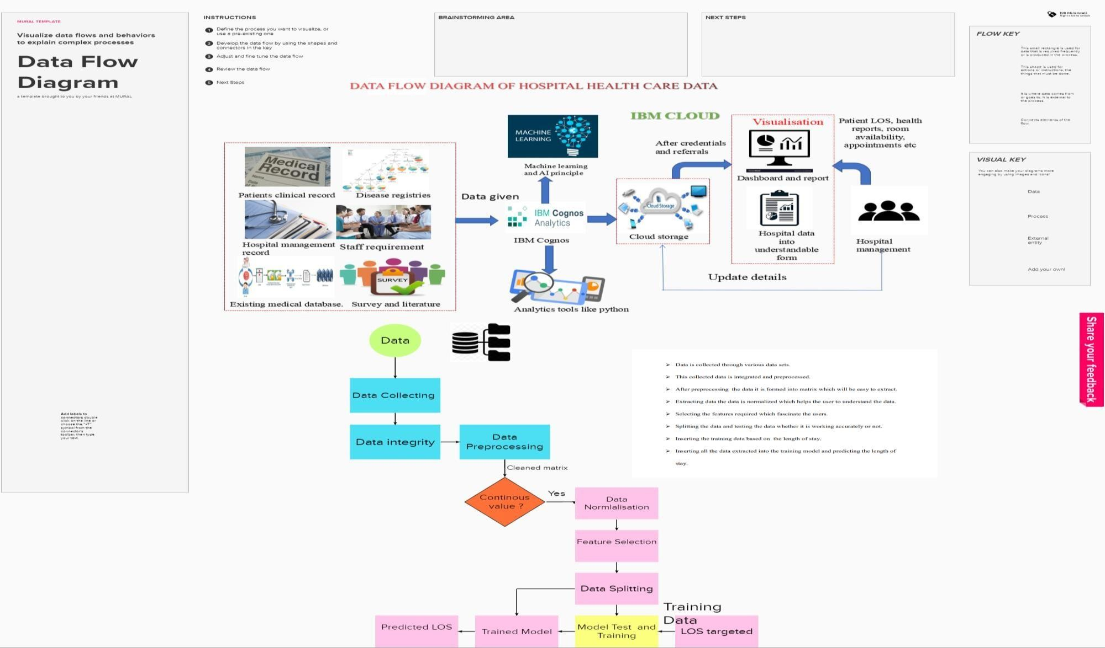

**User Stories**

Use the below template to list all the user stories for the product.

|  |  |  |  |  |  |  |
| --- | --- | --- | --- | --- | --- | --- |
| **User Type** | **Functional**  **Requirement (Epic)** | **User Story Number** | **User Story / Task** | **Acceptance criteria** | **Priority** | **Release** |
| Customer (Mobile user) | HIV/AIDS Risk Smart Form for Data Entry | USN-1 | As a Clinician,I need to review ,consoldate and update HIV/AIDS Risk Form.  So that I can Determine the patient’s risk of HIV/AID(risk caregory),and ensure proper remedy accordingly. | I can access patient record or data accurately | High | Sprint-1 |
|  | BPA to prompt ordering HIV/AIDS on Admission | USN-2 | As an Inpatient, I want to be prompted to order HIV/AIDS on admission.so that I remember to place my patient on AIDS | Maintain the record for correct preference. | High | Sprint-1 |
|  | HIV/AIDS  dynamic order group in Admit order sets | USN-3 | As an inpatient ,I want to view only risk- appropriate HIV/AID options in Admission order sets  So that I can ensure my patient is getting optimal HIV/AID prophylaxis. |  | Low | Sprint-2 |
|  |  | USN-4 | As a user, I can access the data in visualise mode. |  | Medium | Sprint-1 |
|  | Dashboard | USN-5 | As a user, I can access the data from the queries,graph ,pie char |  | High | Sprint-1 |
| Customer (Web user) |  |  | Get the older information from the hospitals |  |  |  |
| Customer Care Executive |  |  | Have data in graph modes |  | Medium |  |
| Administrator |  |  | Access in cloud easily |  | Medium |  |